Task Sequence Flow Step

Objective

Task Sequence Step executes multiple tasks in sequence mode.

UI

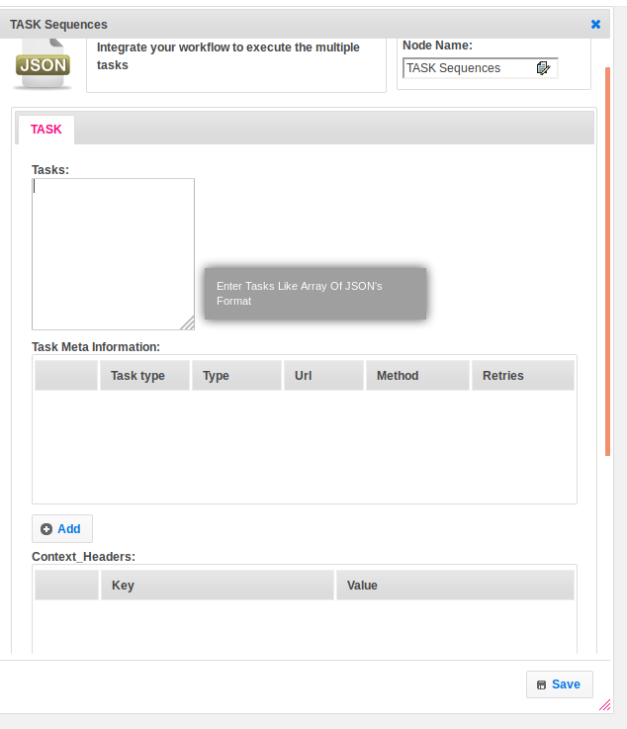

## 

## 

## Attributes

|  |  |
| --- | --- |
| **Attributes** | **Description** |
| **1. Tasks** | Tasks contain an array of JSON. |
| **2. Task Meta Information** | Task metadata contains an array of maps. Each map contains an object of TaskMeta |
| **3. Context_Header** | An array of maps.  Key as header name  Value as header value. |
| **4. Database Plugin** | Provide database plugin information. |
| **5. Select Template** | Select Template used to set the value type.  Value types are two types.  1.hb-HandleBars  2.ftl-Freemarker Template Language. |
| **6. Output Variable** | Used to store the response of the request. |

## Executor Description:

Prepare Task Meta Info map. Prepare the task object. Convert an array of JSON into task object.Create a Task map object and put task_id as key and task object as value. Execute the tasks, start with the first task. Based on type attribute value in tasks object it will execute the rest calls in a task_metadata list when the type matches with task_metadata type.Depends on the success or failure the next task will execute.